SCP Site 19 Game Design Document

Summary

- Build System
  - Overall Presentation & Menu
  - Floor
  - Basic Walls
  - Room
  - Sectors
  - Furnitures
  - Wall with Doors
- Job System
- Game Manager
- Foundation Personnel
- SCP Personnel

Build System
- Menu
The Build Interior Menu shall display list of available rooms.
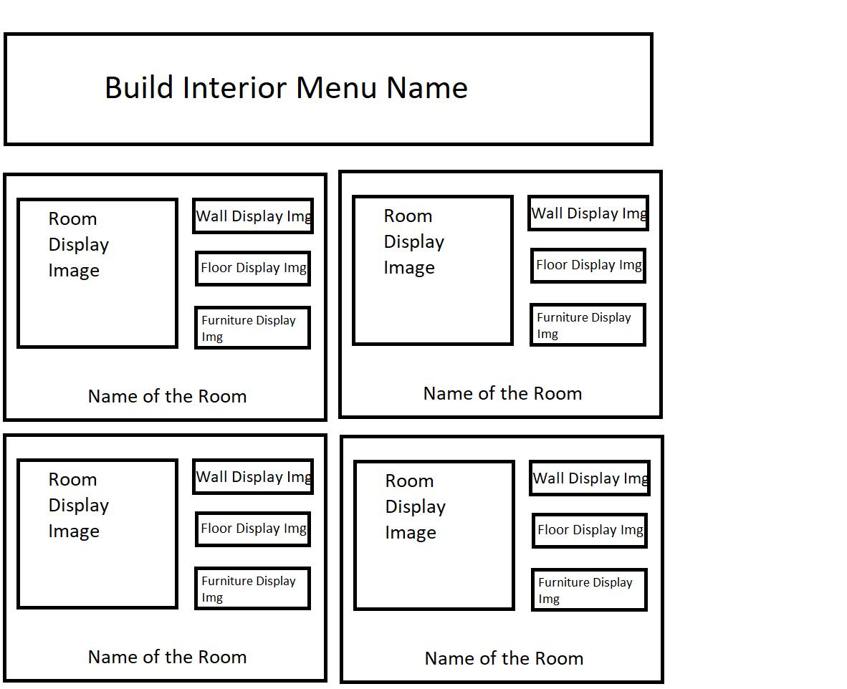

Rooms are unique combinaison of Wall, Floor and Furnitures.
Room types are defined by design, their Floor and Furnitures are non customisable, but the wall is.
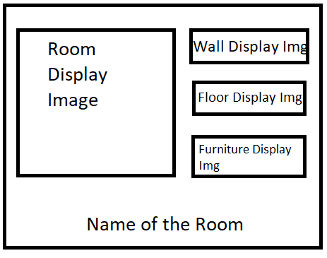
The Room Display Image is showing a preview of the Room with Walls and Floor.
The Wall Display Image is showing a preview of the Wall used. A gear icon will be present at the right of the image, to enable personnalisation of the Wall. Doing so will update the Wall Display Image and the Room Display Image.
The Floor Display Image is showing a preview of the Wall used.

When left-Click on these 3 Display Images, it will set the appropriate building mode and resume the Build Interior Menu.
When mouseover on the 3 Display Images, a tooltip will appear, containing the name and price of the item.

Clicking on the Furniture Display Image will remove all others Building Interior Menu Item and open the Extented Room Menu Item

